BTI425 Lab 1

# Lab Weight:

2% of your final course Grade

# Specification:

### **Steps:**

1. Open books.xml in your browser
2. Go to the developer tools (F12) and run the following command: -document.getElementsByTagName(‘title’) – What happen?
3. open ReadXML-Sample.html in vs-code and understand how it works.

* Change the HTML file in order to display the title of the 1st book in the “demo” section of the page.
* Using the getAttribute() method, extract the “category” value of each “book” and display it in the output.
* Design a JSON file for representing the following information in the HTML page:

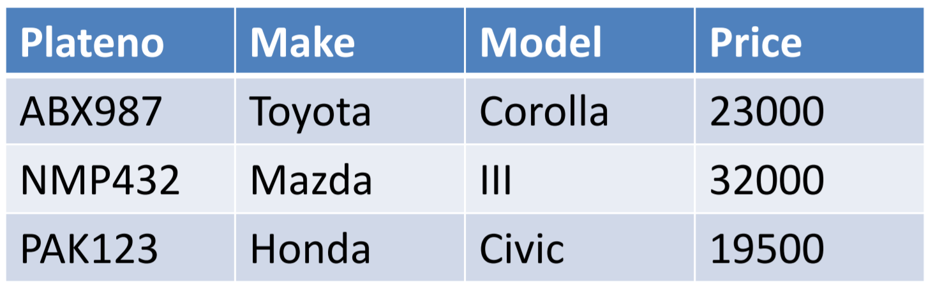

* Save the file as lab1_yourname.JSON and validate the JSON file

## Lab Submission:

* Make sure to answer all the questions in a MSWord file (yourname-lab-week.docx)
  + Add **screenshot** of the output of each activity (pages/programs) in browser
* ZIP all your source files (html,xml, json)
* Submit them into the related entry in the Blackboard
* Note: class labs should be submitted within 24 hours after the lab posted.

## Important Note:

* **NO LATE SUBMISSIONS** for labs. Late lab submissions will not be accepted and will receive a **grade of zero (0)**.
* After the end of the due date, the lab submission link on My.Seneca will no longer be available.